MIDDLE PATH

A virtual workshop for parents/caregivers of youth ages 10-15.
Focus:
- support managing intense emotions
- build emotion regulation skills
- safety plan
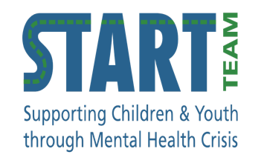

TOPICS COVERED
How to work toward building the relationship you want with your young teen
Understanding how changes in the body and brain which occur in early adolescence contributes to the development of new, and sometimes challenging behaviours.
Keys to communication with young teens.
How to manage intense, sometimes frightening behaviours, and safety planning.
Skills to use with your young teen to support them in developing better emotion regulation strategies going forward.

WHAT YOU NEED TO KNOW
Workshop is skills-focused – participants will not be required share their individual experiences and/or challenges with the group.
Participants are encouraged to ask questions and engage in discussion/reflection, but are not required to do so to attend.

WHEN
Tuesday mornings from 12 July to 16 August 2022
9:30-11am
Six 90-minutes sessions.
Sessions will not be recorded.

RESOURCES
- Parent/Caregiver strategies (4 videos):
https://www.mentalhealthfoundations.ca/parent-coaching

- The Teenage Brain Explained:
https://www.youtube.com/watch?v=hiduiTq1ei8

- Why Parent/Caregiver involvement in the treatment of mental heal issues in young people is essential:
https://www.mentalhealthfoundations.ca/why-we-want-you.

CONTACT
If you are interested in participating, please register with:
Nicole Allen
nicole.allen@fraserhealth.ca
Zoom links will be sent approximately one week prior to the start of the group to registered participants.

