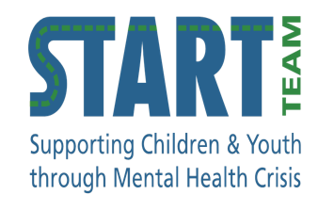
START and IMPACT have partnered to offer:

PARENT GROUP
A 4-week, in-person group for parents/caregivers of young people ages 12-24 years who are substance using.
Provides support, awareness, knowledge, and skills for caregivers.
Talk about what is relevant to you in a supportive and judgement-free environment.

Over the four weeks we will be talking about the questions and lived experience you have in relation to:
- Understanding why substance use occurs

- Building communication skills when talking with your young person

- Setting sustainable boundaries and enhancing connection

- Maintaining the relationship with your young person

WHEN
Thursday evenings from 6-8pm for 4 weeks. Please register to learn about upcoming dates.
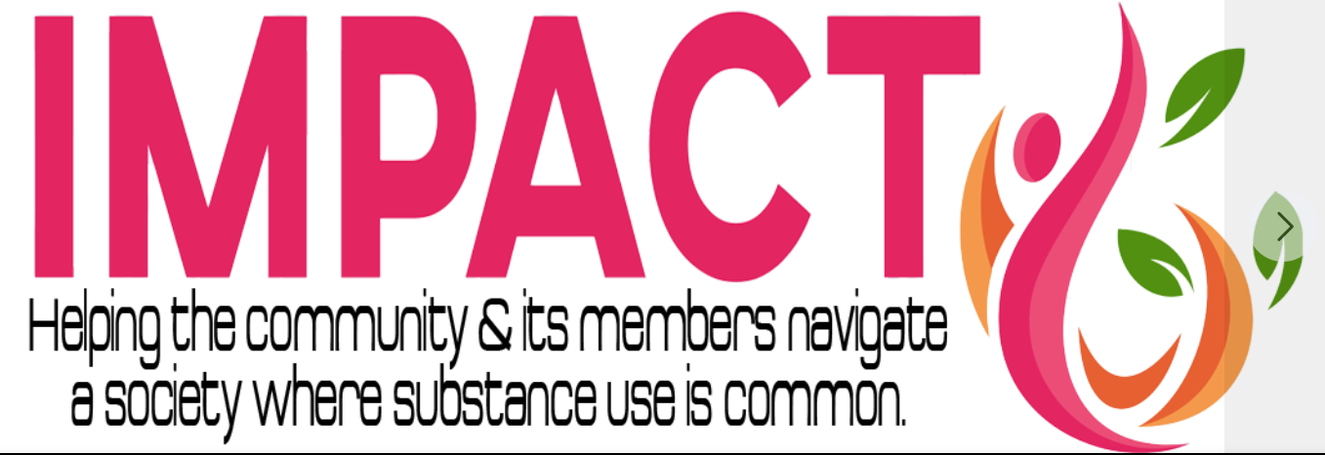

RESOURCES
Province of BC Mental Health and Substance Use resources: https://www.fraserhealth.ca/health-topics-a-to-z/mental-health-and-substance-use#.YnCV5nbMKzV.

Tips for having tough conversations with teens: https://www.healthlinkbc.ca/mental-health-substance-use/parenting-and-substance-use.

Talking to your teens about drugs (video):
https://www.youtube.com/watch?v=EcV58kiIAY4

Reducing Stigma (videos): https://www2.gov.bc.ca/gov/content/overdose/reducing-stigma.

REGISTER
If you are interested in participating, please register with:
Nicole Allen – Group and Family therapist, START East
nicole.allen@fraserhealth.ca

WHERE
101-32555 Simon Avenue, Abbotsford
In person (masks required)

